**Assignment Day 4**

**Question 1: Find out the mail server of following domain:**

**1. ibm.com**

**2. wipro.com**

**Answer:** -

for finding mail server of domain we use nslookup command, after that we use set type = mx and then we enter the domain name of website there and will get the mail server as below:

for [www.ibm.com](http://www.ibm.com/)

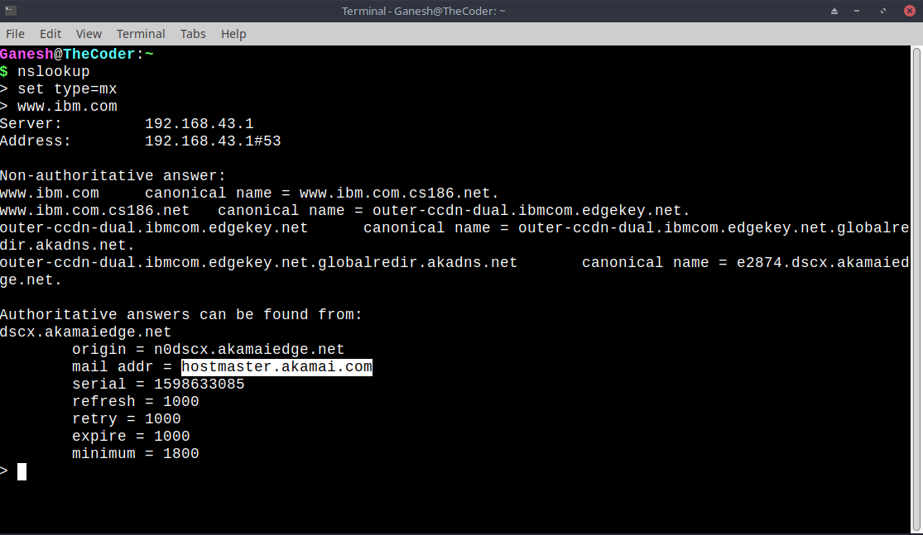

for [www.wipro.com](http://www.wipro.com/)

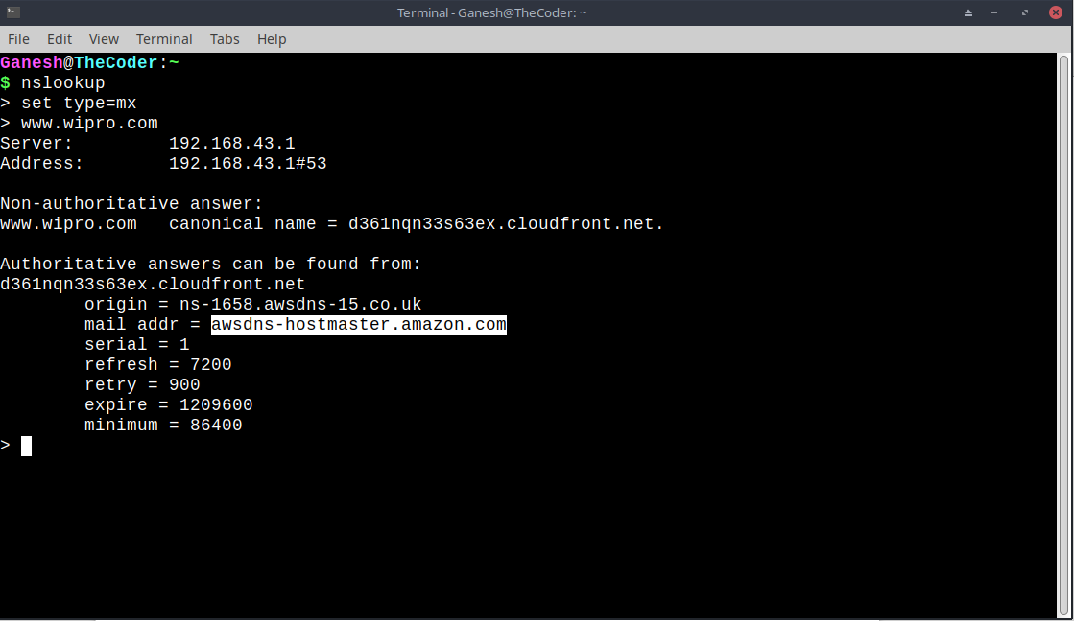

**Question 2 : Find the locations, where these email servers are hosted.**

**Question 3: Scan and find out port number open 203.163.246.23**

**Answer :-** for finding which port are opened we type command

nmap -Pn -sS 203.163.246.23

